***COVID-19 DATA ANALYSIS USING TABLEAU***

**DATASET LINK:** <https://drive.google.com/drive/folders/1pPiCs-x8QuVEfNehzqDQhmL36LwICPt8> (9.29 MB)

**OBJECTIVES:**

1. Total number of confirmed cases in different nations
2. Total number of recovered cases in different nations
3. Total number of confirmed cases in India
4. Total number of recovered cases in India
5. Forecast trend line for COVID-19
6. Group Indian states and find Covid-19 hits
7. Find the highest death rate in international level
8. Find the least death rate
9. Find the variation in covid-19 cases around the world

**STEPS:**

1. Import the covid_19_data excel file.

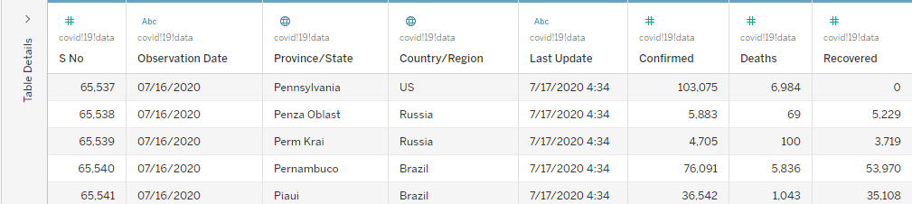

1. Use the data interpreter to clean the data.

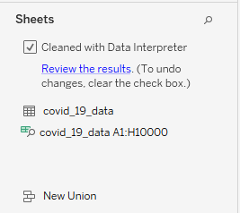

1. Total number of confirmed cases in different nations

Created a map and added country/region and confirmed cases values. Changed the color to get a better perspective

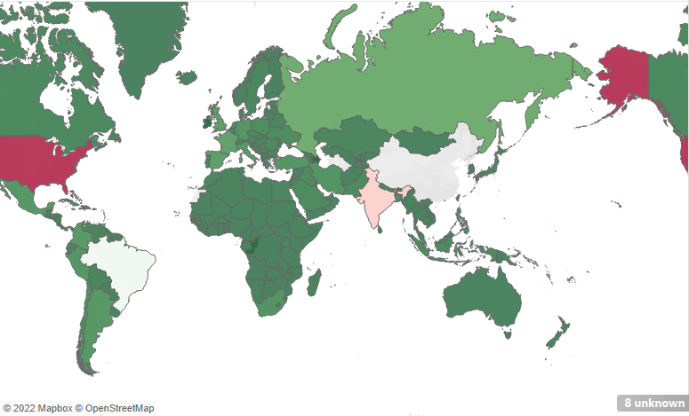

1. Total number of recovered cases in different nations

Created a map and added country/region and recovered cases values. Changed the color to get a better perspective

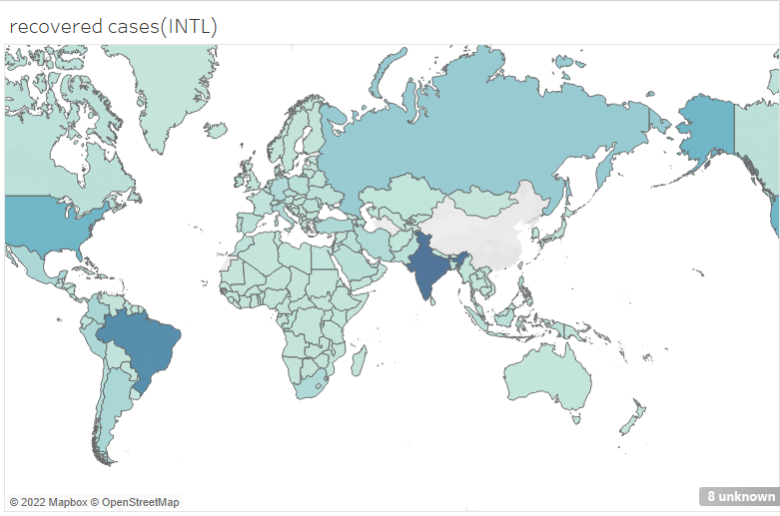

1. Total number of confirmed cases in India

Added country/region to the rows and filtered India. Added confirmed values to the row value and state/province to the column value.

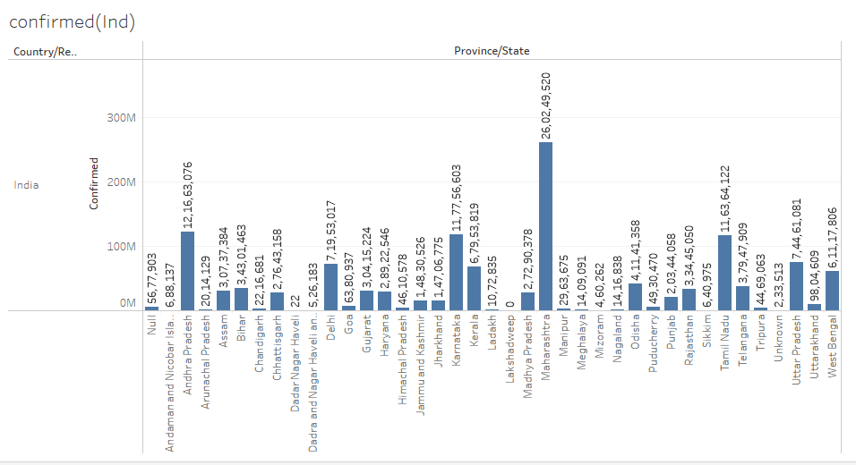

Pie chart representation:

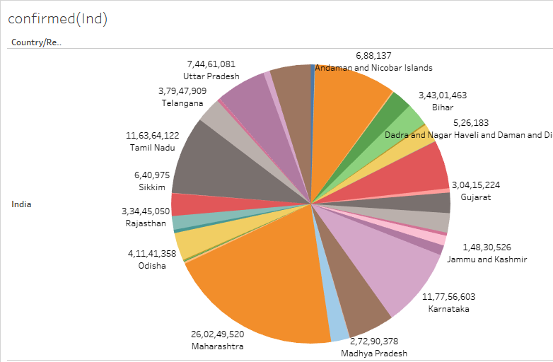

1. Total number of recovered cases in India

Added country/region to the rows and filtered India. Added recovered values to the row value and state/province to the column value.

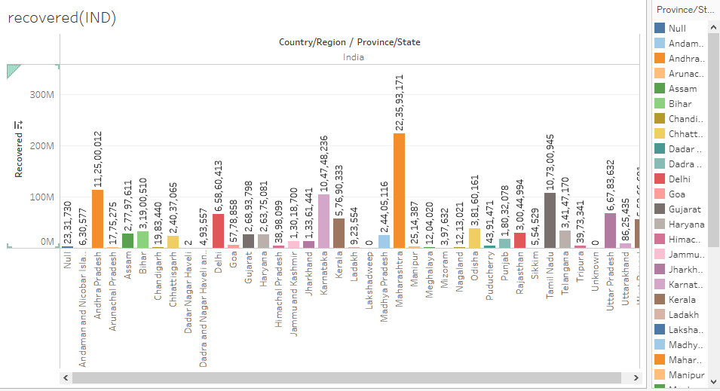

Pie chart:

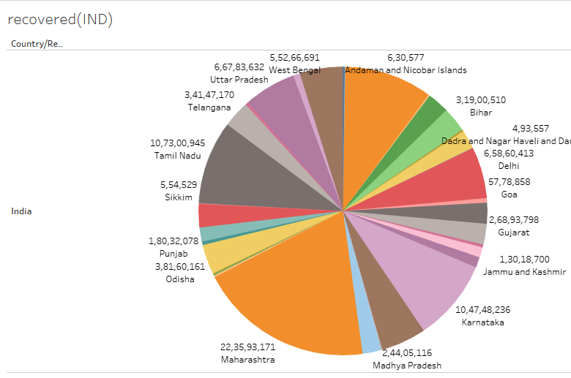

1. Forecast trend line for COVID-19

Create a line graph with last update and confirmed cases value. Change the last update data type to date.

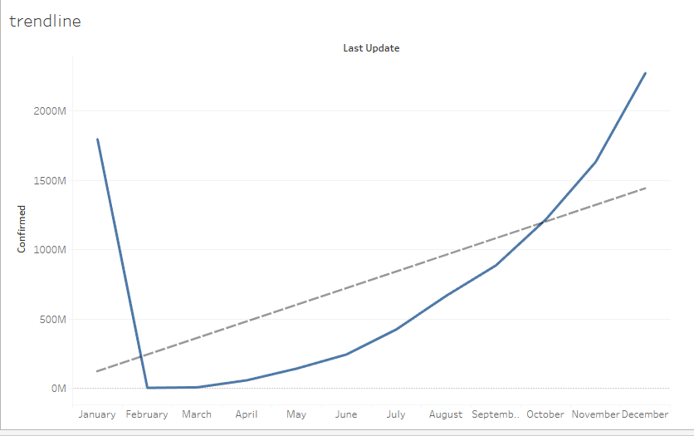

Trend line for India:

In filter add country and select “India”

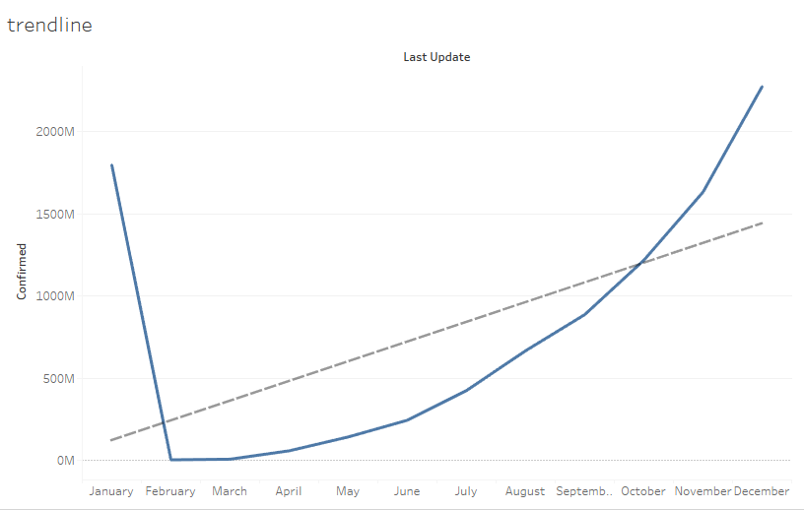

1. Group Indian states and find Covid-19 hits

Right click on Province/State and select all the Indian states and UTs and click Okay

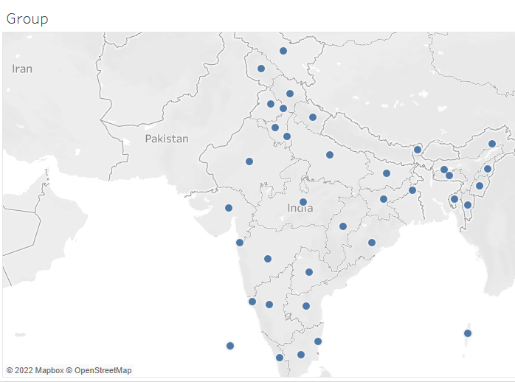

1. Find the highest death rate in international level

Create a table with the fields Country/Region, Confirmed and deaths. Click the sort icon in the death column

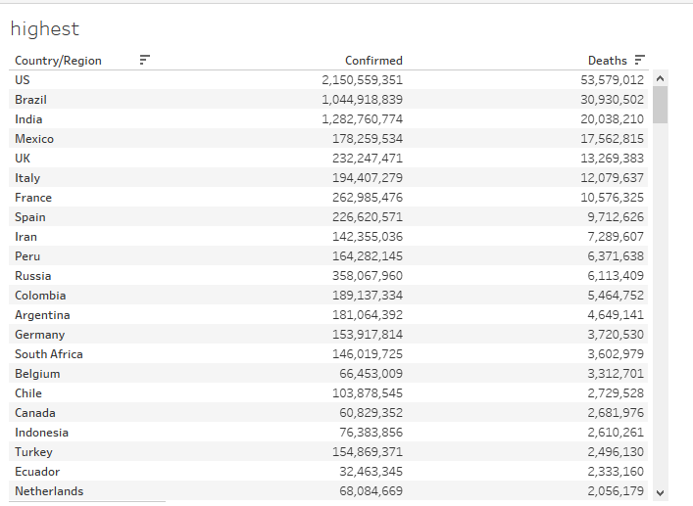

1. Find the least death rate

Create a table with the fields Country/Region, Confirmed and deaths. Click the sort icon in the death column

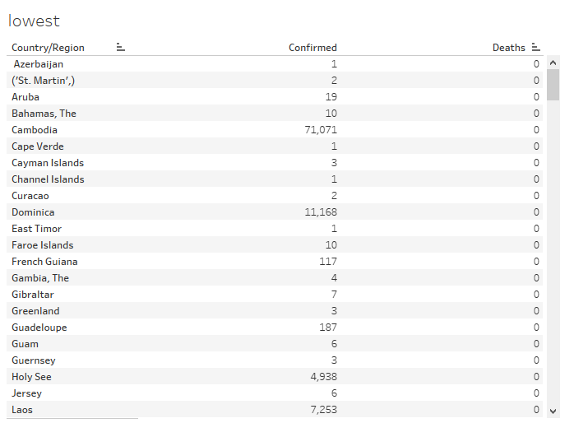

1. Find the variation in covid-19 cases around the world

Create a box and whisker plot with country and confirmed cases. Uncheck aggregate values.

Sort descending

